**ODD+D Description – The Migration, Intensification, and Diversification as Adaptive Strategies (MIDAS) model framework**

This document follows the ODD+D protocol to describe agent-based models with individual decision-making (Müller et al. 2013). This document describes properties of the MIDAS framework, while refraining from describing specific implementations (models) constructed from the MIDAS framework.

**I OVERVIEW**

**I.i Purpose**

*I.i.a What is the purpose of the study?*

The purpose of this model (hereon, MIDAS) is to simulate livelihoods decision making at the individual and household level, including intensification (focus on a small number of activities for income), diversification (spreading across a larger number of activities for income), and migration (changing locations to access opportunities for income), as functions of available opportunities varying in space and time.

Examples of appropriate questions for an application of MIDAS might include:

* How important are household social ties in mitigating income shocks?
* What kinds of social programs can best help families adapt to long-term agricultural droughts?
* How can the spread of urban services to rural areas stem the flow of rural-to-urban migration?
* How does geographic dispersion benefit communities?

*I.i.b For whom is the model designed?*

This model is designed for researchers in the area of livelihoods, migration, and household decision-making or risk management.

**I.ii Entities, state variables and scales**

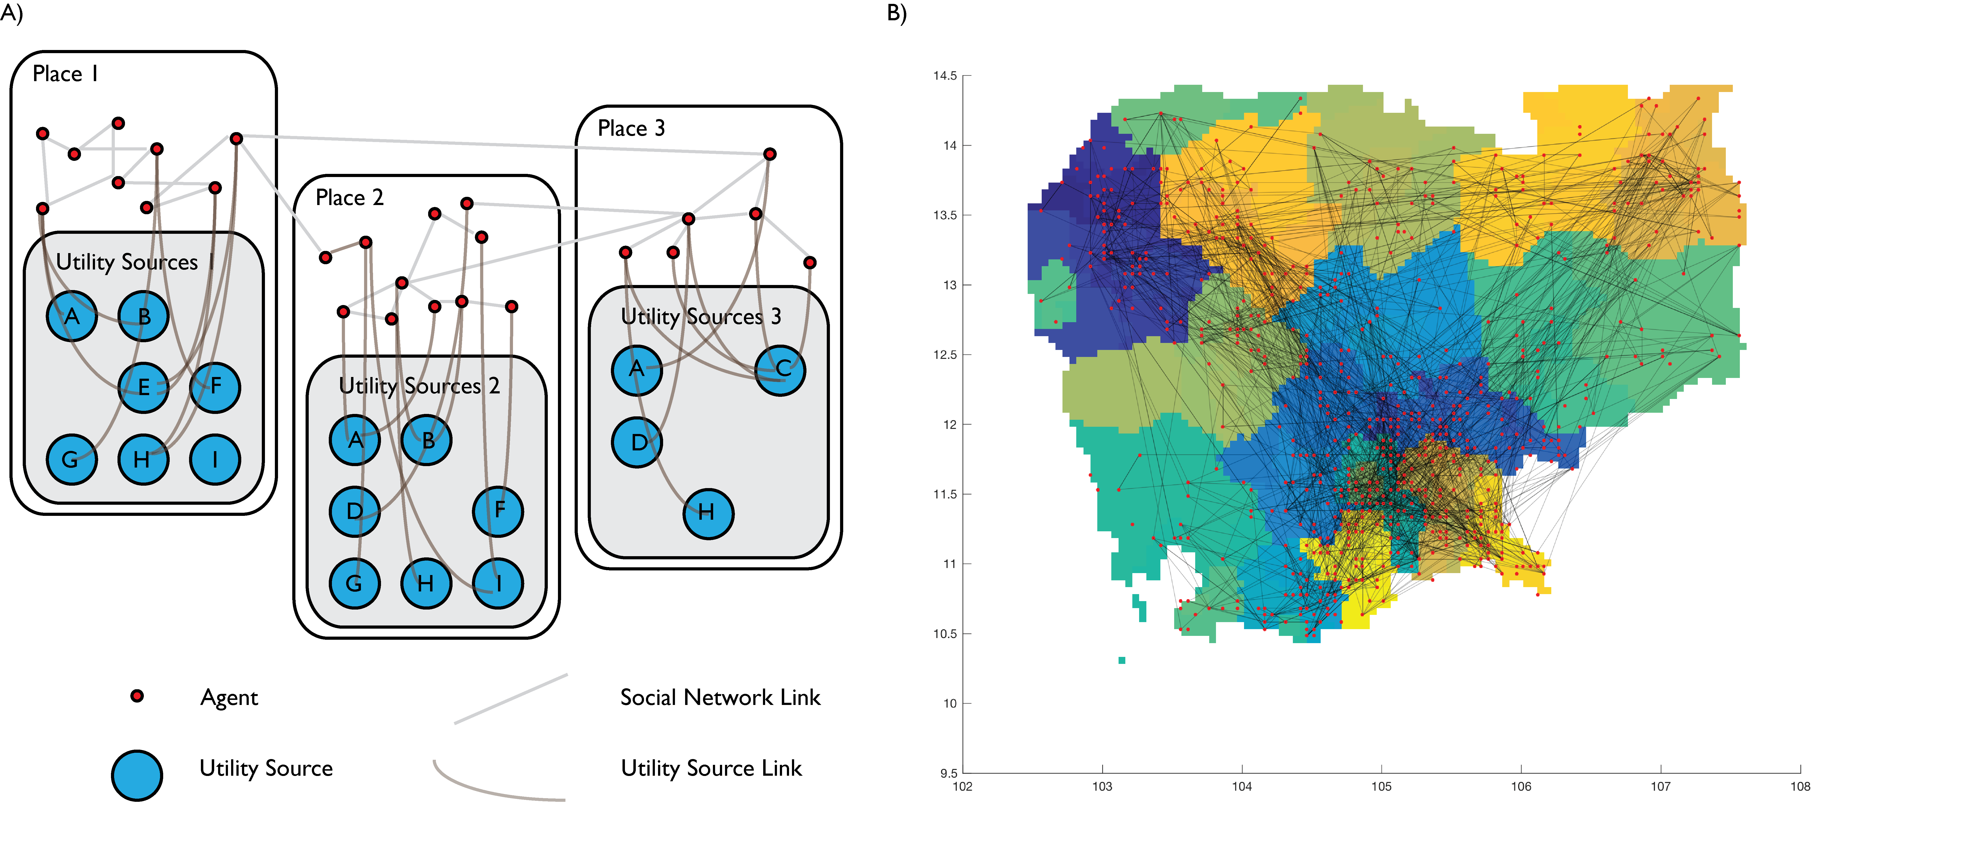

**Figure 1: A) Agents located in places, embedded in a social network, and drawing from utility sources as in the MIDAS framework; B) Sample visualization of agents in a two-dimensional representation of Cambodia in a MIDAS simulation.**

*I.ii.a What kinds of entities are in the model?*

MIDAS models individual agents deriving livelihoods, connected to each other by social networks, and existing at particular ‘places’ – points in a two-dimensional space.

*I.ii.b By what attributes (i.e. state variables and parameters) are these entities characterized?*

Agents are described by the parameters outlined in Table 1.

The social network links between any two agents *i* and *j* are described by two network strength parameters *Sij* and *Sji*, denoting the closeness of each one-way relationship.

Places (or nodes) are described by a location in two-dimensional space, a set of administrative identifiers of variable length (e.g., country, state, county, district, etc.), the potential value of any utility layers included in the simulation at that place, as well as the set of particular costs an agent must assume in order to access that utility layer at that place (Figure 1A).

The values taken by utility layers may be provided as input to the model (i.e., fully exogenous), determined internally by model properties (i.e., fully endogenous) or some mix of both.

*I.ii.c What are the exogenous factors/drivers of the model?*

The universe of available utility layers (which may represent income opportunities, assets, or any other concept from which agents may derive utility) is exogenous to the model. The values taken in space and time for each of these layers may be partially or fully exogenous to the model. Additionally, the location of places occupied by the agents, and the structure of the social network among agents, are determined exogenously at initialization.

**Table 1 – Agent Parameter List**

|  |  |  |
| --- | --- | --- |
|  | **Parameter** | **Description** |
| ***Determined on initialization*** | **id** | Identifier for each agent |
| **Gender** | Gender of agent |
| **incomeShareFraction** | Fraction of income to the agent shared across social network in a given timestep |
| **shareCostThreshold** | Fraction of the overall amount of a remittance lost to transaction costs, above which the agent will choose not to make that share |
| **knowledgeShareFrac** | Fraction of their accumulated knowledge (of opportunities in other places) shared with agents during social interaction |
| **pInteract** | Likelihood of current agent to interact with other agents to exchange information in a given timestep |
| **pMeet** | Likelihood of current agent to meet a new agent in a given timestep |
| **pChoose** | Likelihood of current agent to make a decision about income portfolio in a given timestep |
| **pRandomLearn** | Likelihood of current agent to learn new information about income opportunities randomly in a given timestep |
| **countRandomLearn** | Number of new pieces of information learned randomly, if agent learns randomly during a timestep |
| **numBestLocation** | Number of good node/locations agent will retain in memory from previous decision making |
| **numBestPortfolio** | Number of good portfolios from a given location agent will retain in memory from previous decision making |
| **numRandomLocation** | Number of node/locations agent will draw randomly in decision making |
| **numRandomPortfolio** | Number of portfolios in a given location agent will draw randomly in decision making |
| **numPeriodsEvaluate** | Number of time periods over which agent will evaluate and compare different portfolios when making a decision |
| **numPeriodsMemory** | Number of time periods of past experience agent will hold in memory to inform decisions |
| **discountRate** | Agent's individual discount rate on future time periods |
| **rValue** | Agent's individual constant relative risk aversion coefficient |
| **bList** | Agent’s individual utility preferences on different forms of utility (income, use value, etc.) available in the simulation |
| **pA** | Agent’s highest expectation of accessing a layer given that a slot is known to be available |
| **pB** | Agent’s highest expectation of accessing a layer when it is not known whether a slot is avaiable |
| **location** | Identifier for the specific node/location where the agent is located |
| ***Updated endogenously*** | **age** | Age of agent (determined upon initialization and then updated) |
| **wealth** | Cumulated wealth of the agent |
| **incomeLayersHistory** | Agent's cumulated knowledge of past income opportunities (through experience, random learning, and social interaction) |
| **bestPortfolios** | Retained list of income portfolios in various locations considered during previous decisions |
| **accessCodesPaid** | List of costs already accrued by the agent to access particular layers (e.g., teaching licenses, necessary equipment, etc.) |
| **currentPortfolio** | Agent's current portfolio of income layers accessed |
| **network** | List of other agents to which current agent has a social connection, with link strength from 0 to 1 (determined upon initialization and then updated) |
| **pChild** | Likelihood of current agent to have a child in a given timestep, informed by age-specific fertility data |
| **pDie** | Likelihood of current agent to die in a given timestep, informed by age-specific mortality data |
| **pOpening** | Agent expectation of layers in different places having available openings |

*I.ii.d If applicable, how is space included in the model?*

Agents occupy specific ‘places’ or nodes in two-dimensional space, with each node representing a hub of utility opportunities that agents may access, and in some cases (such as where the values of utility layers are defined by the user as density dependent) compete for. Depending on the definitions in input data, these points may represent villages, cities, counties, states, or other administrative divisions.

*I.ii.e What are the temporal and spatial resolutions and extents of the model?*

MIDAS is built with a flexible timescale and temporal resolution. There is an underlying ‘timestep’ within which MIDAS will cycle once through all agents and allow them to act, and may also evaluate and update utility. This underlying timestep could be daily or weekly (as in wages), seasonally (as in harvests), or any other division the modeler deems appropriate. There are several other implicit timescales that are loosely coupled to this base timestep during a model run: i) social interactions, ii) portfolio evaluations, and iii) random learning. Each agent has an individual-specific likelihood of participating in each of these processes, tested during each timestep. In this manner, the exchange of information or the making of life choices is not spuriously coupled to the regular passage of time – some agents may interact regularly while others do not, some may make changes to their income portfolios often, others seldom. The evaluation of utility occurs at regular multiples of the underlying timestep. With this structure, MIDAS can create conditions for work-week commuting, seasonal migration, as well as long-term patterns of immigration.

The spatial resolution and extent of the model is defined exogenously by the scope of input map data.

**I.iii Process overview and scheduling**

*I.iii.a What entity does what, and in what order?*

In a single timestep, MIDAS first loops once through all agents in a newly randomized ordering, testing whether they participate in communication with other agents, random learning, or whether they update decisions about their best utility portfolio (Figure 2). Following this agent loop, if utility is to be evaluated and received by agents in the current timestep, MIDAS takes an additional loop to do so – calculating utility first, then looping through each agent to receive new utility and share across their social networks (Figure 2).

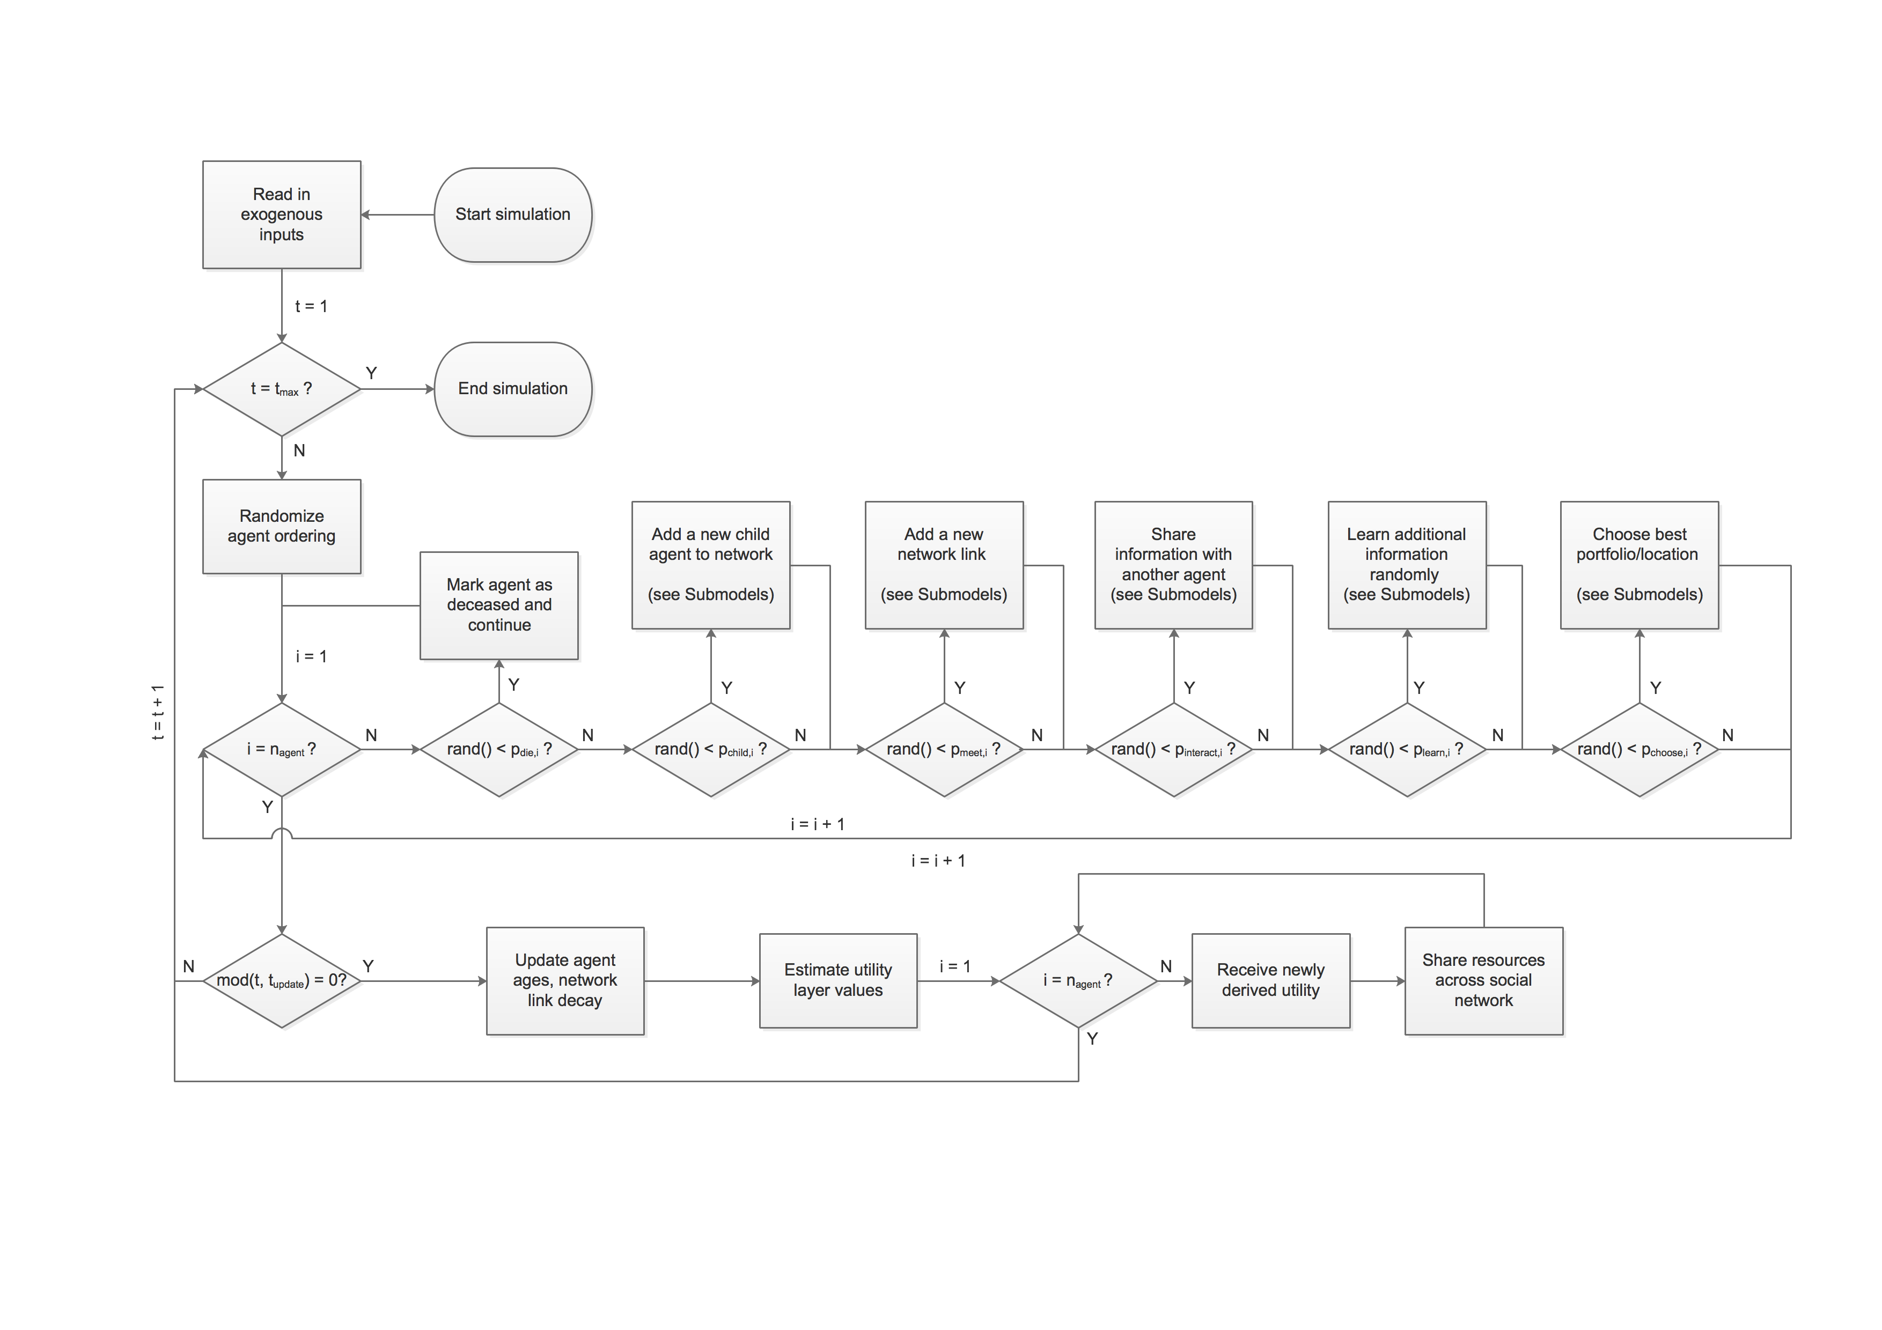

**Figure 2: MIDAS process flow overview. Agent information sharing, learning, and decision flow diagrams included in Submodels section.**

**II DESIGN CONCEPTS**

**II.i Theoretical and Empirical Background**

*II.i.a Which general concepts, theories or hypotheses are underlying the model’s design at the system level or at the level(s) of the submodel(s) (apart from the decision model)? What is the link to complexity and the purpose of the model?*

There are no particular literatures that inform the system-level or submodel behavior of MIDAS, outside of the decision model. Many of the modeler’s assumptions regarding system-level behavior will be implicit in the utility layers provided as input to a specific implementation of MIDAS, which can represent income, assets, or any other aspect of an agent’s environment from which it might derive utility. Spatiotemporal patterns in these input layers, or equations governing their calculation, will embed specific modeling assumptions regarding system behavior and should be described in each instantiation.

*II.i.b On what assumptions is/are the agents’ decision model(s) based?*

The decision model used in the current MIDAS version (described below in II.ii and in Submodels) embeds the following assumptions with roots in decision literature:

* Factors shaping livelihoods decisions (of which migration is one) are well described by ‘pushes’ (declines in opportunity local to the agent), ‘pulls’ (availability of opportunities distant from the agent), and ‘moorings’ (investments and ties – such as assets or family – that cannot be easily moved with the agent) (Moon 1995, Stimson and McCrea 2004).
* Decisions regarding portfolios of livelihoods opportunities are boundedly rational, such that only a small number of possible competing opportunities are considered at one time (Rubenstein 1998, Kahneman 2003).
* Given two income streams of equal nominal value, a risk-averse agent should prefer the less time-varying of the two, such that a livelihoods portfolio that spreads activities across activities with uncorrelated risks (diversification) can be a risk minimization strategy; this can be accomplished via an expected utility framework (Feder 1980, Bert et al. 2011, Hong 2015) based on constant relative risk aversion (Dave et al. 2010).
* In considering future income streams, agents will dislike losses approximately twice as strongly as they enjoy equivalent games, as in prospect theory (Kahneman 2003, Schlüter et al. 2017).

*II.i.c Why is/are certain decision model(s) chosen?*

The set of assumptions outlined above that bound the decision model have been chosen in order that: i) migration can emerge as an adaptive strategy alongside other livelihoods strategies (such as diversification or intensification) without being hard-coded in (e.g., as a stage-wise decision), ii) preferences for crop diversification along a season, or commuting/local migration over short periods, can emerge in the same modeling space, and iii) factors outside of income, such as assets or preferences for family connection, can shape livelihoods decision-making (conditional on the availability of data on relative preferences).

*II.i.d If the model/submodel (e.g. the decision model) is based on empirical data, where do the data come from?*

This document describes the MIDAS framework rather than any specific implementation within it. In general, utility layers should be informed either by primary data collection or secondary sources such as censuses or living standards surveys. The relative value to the agent of those different layers (when they do not directly show income, but use value or existence value) should be informed by experimental means (such as discrete choice experiments).

*II.i.e At which level of aggregation were the data available?*

In general, the aggregation scale of availability of secondary data (like income) will constrain the scale of the model. Secondary income data are commonly available from census or representative sample surveys down to state or county levels.

**II.ii Individual Decision-Making**

*II.ii.a What are the subjects and objects of the decision-making? On which level of aggregation is* *decision-making modeled? Are multiple levels of decision making included?*

Individual agents make decisions on the best portfolio of utility-yielding activities (including income sources, assets, as well as any other feature from which an agent may derive utility over time) across a sample of different places, including their current place and current portfolio.

*II.ii.b What is the basic rationality behind agent decision-making in the model? Do agents pursue an explicit objective or have other success criteria?*

Agents pursue a strategy of maximizing expected utility over time.

*II.ii.c How do agents make their decisions?*

Agents first select a sample of places in the modeled space for which they have some information about utility opportunities, and then select a sample of portfolios in each place. An agent-specific fraction of these places (and portfolios within places) are remembered from previous decision-making; the remaining fraction is drawn randomly. Drawing from their knowledge of past values from these utility layers, agents estimate the future utility stream (converted to a net present value) that would be derived from these portfolios, including any initial costs to move to new locations or access new utility layers, using an expected utility modeling framework (See *Submodels*).

*II.ii.d Do the agents adapt their behavior to changing endogenous and exogenous state variables? And if yes, how?*

Agents maintain a finite memory of past observation and shared information, so that as utility of different layers changes over time and as they learn more information, their evaluation of expected utility will change.

*II.ii.e Do social norms or cultural values play a role in the decision-making process?*

Not explicitly in the version of MIDAS presented here.

*II.ii.f Do spatial aspects play a role in the decision process?*

The initial costs associated with income streams will include moving costs if appropriate, and the costs of sharing resources across the social network are location dependent, thus shaping the expected utility stream of a portfolio.

*II.ii.g Do temporal aspects play a role in the decision process?*

Timesteps in MIDAS are defined as occurring in ‘cycles’ that are known to agents (e.g. 12 steps in a ‘year’ of months or 3 steps in a ‘year’ of seasons. Agents consider cycles in estimating future utility streams, preserving cycles of estimated value along time and across layers wherever their ‘memories’ permit (in order to capture any correlation over time across layers).

Agents age over time, and MIDAS allows for agent age to affect a range of agent parameters (such as time horizon for decision making) via scripts specific to an implementation of MIDAS. Agents may die or have children, following age-specific mortality data. Additionally, agent social networks decay over time, and will weaken unless they are enhanced again by interactions or the sharing of remittances

*II.ii.h To which extent and how is uncertainty included in the agents’ decision rules?*

In the present version of MIDAS, utility values are specific to a time and place, but not to an agent – all agents accessing a layer at the same place and time receive the same value, without uncertainty or variation. Future versions may have agent-specific multipliers, but this is not currently an object of inquiry. The benefit of this structure is improved memory management and scalability, as the history of incomes is stored in only one place.

Uncertainty manifests in decision-making only by way of agents’ incomplete knowledge of historic/future utility streams, such that their estimations (constructed with existing memory and filling in gaps as best as they can) are imperfect guesses at what the future stream may be.

**II.iii Learning**

*II.iii.a Is individual learning included in the decision process? How do individuals change their decision rules over time as consequence of their experience?*

In the present version of MIDAS, the decision rule remains fixed. Agents build out their best estimate of future utility streams based on their current knowledge, so that as they learn more (by doing, interacting, or learning randomly) their estimations of the value of different portfolios will change. Additionally, as they consider different portfolios and retain their memories of good options, the quality of portfolios compared in subsequent decisions is improved.

*II.iii.b Is collective learning implemented in the model?*

Agents share elements of their own knowledge with other agents in their social network via social interaction.

**II.iv Individual Sensing**

*II.iv.a What endogenous and exogenous state variables are individuals assumed to sense and consider in their decisions? Is the sensing process erroneous?*

Agents consider their past history of experience and knowledge with the utility layers available in the model, known costs of accessing those layers, known costs of moving, past experience of receiving other support across their social networks and known costs of sharing across their social networks. This process is not erroneous.

*II.iv.b What state variables of which other individuals can an individual perceive? Is the sensing process erroneous?*

Agents remember sharing across their social networks, without error. However, this is an imperfect prediction of future structure and sharing across their social networks.

*II.iv.c What is the spatial scale of the sensing?*

Agents are able to learn randomly about past history at any place in the modeled space, and as well can learn any aspects of past knowledge from members of their social network.

*II.iv.d Are the mechanisms by which agents obtain information modeled explicitly, or are individuals simply assumed to know these variables?*

Agents are assumed to know the costs of accessing utility layers, the costs of moving and the costs of sharing across their social networks. Information regarding utility layer values at particular places and times is learned through experience, sharing of information via social interaction, and random learning.

*II.iv.e Are the costs for cognition and the costs for gathering information explicitly included in the model?*

There are no explicit search costs in this version of MIDAS, nor is exploration modeled as a decision. It is modeled as a probabilistic process, such that costs, willingness and ability to search are implicit in the likelihood an agent has to interact socially or learn randomly.

**II.v Individual Prediction**

*II.v.a Which data do the agents use to predict future conditions?*

Agents use their knowledge of past utility values, in different places and times, to predict future conditions. To the extent possible, agents preserve the time structure of past knowledge across utility layers, in order to capture patterns across layers and along time.

*II.v.b What internal models are agents assumed to use to estimate future conditions or consequences of their decisions?*

Agents implement an expected utility model of future utility streams.

*II.v.c Might agents be erroneous in the prediction process, and how is it implemented?*

Agents are only erroneous to the extent that past performance (and their incomplete knowledge of it) is an imperfect prediction of the future.

**II.vi Interaction**

*II.vi.a Are interactions among agents and entities assumed as direct or indirect?*

Agents interact directly via social interactions that include the exchange of knowledge of past utility, and by sharing their received utility across their social networks.

*II.vi.b On what do the interactions depend?*

Interactions depend on i) the structure of social networks, including a network link ‘strength’ that is one way (i.e., agent *i* can have a stronger/weaker connection to agent *j* than agent *j* has to agent *i*); ii) the cost of sharing between the places occupied by any two agents in a social network; iii) and the agent-specific probabilities of participating in a social interaction in a given timestep.

*II.vi.c If the interactions involve communication, how are such communications represented?*

Communication between agents happens in two places. In social interactions, an agent shares a fraction of their cumulative knowledge of past utility values (drawn randomly) with the other agent in the interaction. In sharing resources, agents have an agent-specific share of their received utility that they share across their social network, proportional to the strength of the network link they share to those agents. Within that interaction, there is an agent-specific threshold fraction of the overall ‘remittance’ that the agent is willing to spend on the cost of remitting; when this cost is exceeded, the agent simply does not share the resource with that agent.

*II.vi.d If a coordination network exists, how does it affect the agent behavior? Is the structure of the network imposed or emergent?*

The structure of social networks is imposed at initialization, and is allowed to evolve over the length of the simulation. At both initialization and during the simulation, new links to the current agent are formed by applying weights to all other agents not in the current agent’s network, according to factors like i) whether the agent is in the same place as the current agent, ii) whether the agent has common social network connections to the current agent, and iii) whether the agent occupies the same layer (in the same place) as the current agent. Such weights will be implementation-specific, and agents with greater weight will be more likely to be selected to be a new link (see Submodels).

**II.vii Collectives**

*II.vii.a Do the individuals form or belong to aggregations that affect and are affected by the individuals? Are these aggregations imposed by the modeler or do they emerge during the simulation?*

Individual agents are embedded in social networks, among agents that may be in the same or in distant places, and with each directional link described by a ‘strength’. At present, these links do not evolve along the length of the simulation, but they may be allowed to do so in future versions. ‘Households’ may be created through parameterization of social networks, constructed as small cliques of agents with close, strong network links. Future versions of MIDAS in which agents may join the model (or be born), or in which network links may otherwise change (through working together, sharing resources or information), will be able to simulate emergent households.

*II.vii.b How are collectives represented?*

Collectives are represented only as a set of social network linkages.

**II.viii Heterogeneity**

*II.viii.a Are the agents heterogeneous? If yes, which state variables and/or processes differ between the agents?*

At initialization, agents differ in a number of the key parameters listed in Table 1: incomeShareFraction, shareCostThreshold, knowledgeShareFrac, pMeet, pChild, pDie, pInterac, pChoose, pRandomLearn, countRandomLearn, numBestLocation, numBestPortfolio, numRandomLocation, numRandomPortfolio, numPeriodsEvaluate, numPeriodsMemory, discountRate, bList, and rValue. These values are all drawn from normal distributions and rounded to integers as appropriate. Additionally, agents will differ in the number of social network connections and the strength of their linkages.

Agents will also accumulate knowledge and make decisions differently along the course of the simulation.

*II.viii.b Are the agents heterogeneous in their decision-making? If yes, which decision models or decision objects differ between the agents?*

Agents do not differ in the structure of their decision-making, only in the decision-related parameters outlined above.

**II.ix Stochasticity**

*II.ix.a What processes (including initialization) are modeled by assuming they are random or partly random?*

In initialization, agent properties and locations, initial utility layer uses, as well as social network links and strengths are drawn stochastically. Along the simulation, agent ordering is randomized in each timestep, and agent participation in social interaction, random learning, or decision-making is also stochastic.

**II.x Observation**

*II.x.a What data are collected from the ABM for testing, understanding and analyzing it, and how and when are they collected?*

This document describes the MIDAS framework, and specific implementations may opt to extract different outcomes. Examples of useful outcomes from MIDAS simulations include the distribution of agents’ overall wealth, the rates of in- and out-migration at all administrative levels, the degree of diversification in income and overall livelihoods of individual agents, and degree of diversification of economies of places.

*II.x.b What key results, outputs or characteristics of the model are emerging from the individuals? (Emergence)*

Migration rates, place-specific economic productivity, and livelihoods diversity of individuals, ‘households,’ and communities are examples of system-level outcomes emerging from individual decisions.

**III DETAILS**

**III.i Implementation Details**

*III.i.a How has the model been implemented?*

The current version of MIDAS is implemented in Matlab, compatible at least up to version 2017a.

*III.i.b Is the model accessible, and if so where?*

Model code and documentation is available at Github, via DOI: 10.5281/zenodo.154738

**III.ii Initialisation**

*III.ii.a What is the initial state of the model world, i.e. at time t = 0 of a simulation run?*

At initialization, the present version of MIDAS assigns new agents to places proportionally based on population estimates (or any table that assigns relative weights to each place). Agents are randomly assigned to access utility layers available in their current place, and have no memory of previous utility values. Agents will occupy these layers and places, having social interactions and learning randomly, without examining other potential portfolios for a period of *tspinup*, accumulating information about other layers and places.

*III.ii.b Is the initialization always the same, or is it allowed to vary among simulations?*

Matlab’s random number generator can be seeded to reproduce identical results; otherwise, each new simulation run will be different, as agent generation (and placement) is stochastic.

*III.ii.c Are the initial values chosen arbitrarily or based on data?*

Population data and utility layers can be drawn from available data or assigned arbitrarily; distributions for agent parameters as well may be informed by experimental data or defined by calibration.

**III.iii Input Data**

*III.iii.a Does the model use input from external sources such as data files or other models to represent processes that change over time?*

Utility layers may be exogenous in full or in part, and may represent scenarios of time variant processes. Additionally, data on agent fertility and mortality, the costs of moving and sending remittances, and any other data that better describe the model context may be added via scripts.

**III.iv Submodels**

*III.iv.a What, in detail, are the submodels that represent the processes listed in ‘Process overview and scheduling’?*

**Submodel 1** **– Childbirth**. This decision process is best described by the pseudocode below:

* Female agent *i* gives birth to a new agent *k* that is randomly male or female
* Agent *k* is added to the network with (initially) only the parent as the social network (but this network can evolve over the simulation)

**Submodel 2** **– New network connection**. This decision process is best described by the pseudocode below:

* All agents *j*≠*i* not in the social network of agent *i* are weighted according to factors shaping the likelihood of meeting, by:

$$W_{j≠i}=\sum_{m}{w_{m}∙S_{m}}$$

where wm is the weight assigned to factor m (which might be distance, number of shared social connections, etc.) and Sm is the implementation-specific score assigned to factor m (factors might all be rescaled to vary from 0 to 1, for example).

* MIDAS creates a cumulative summation of these weights, and normalizes by the sum of all weights, creating a vector spanning 0 to 1
* A new link is selected by drawing a random number between 0 and 1, and selecting the agent corresponding to the first value in the normalized cumulative sum vector that is larger than that random value

**Submodel 3** **– Social interaction**. This decision process is best described by the pseudocode below:

* Agent *i* chooses a random member agent *j* of social network
* Identify non-overlapping knowledge sets of past utility layers (across places and times) for agents *i* and *j*
* Agent *i* shares *fshare fraction, i* of knowledge held by agent *i* but not agent *j*, with agent *j*
* Agent *j* shares *fshare fraction, j* of knowledge held by agent *j* but not agent *i*, with agent *i*

**Submodel 4** **– Random learning**. This decision process is best described by the pseudocode below:

* Agent *i* learns *nrandomLearn, i* pieces of information (e.g., specific utility values from a particular layer, place, and time), drawn randomly.

**Submodel 5** **– Livelihoods decision**. This decision process is best described by the pseudocode below:

* Choose a set of locations to consider – *nbest,loc* locations with good options from previous decision-making, and *nrandom,loc* locations chosen randomly, as well as the current location.
* For each location,
  + Choose a set of *ntotal* portfolios - *nbest,port* portfolios with high value remembered from previous decision-making (if available), and max(*ntotal - nbest,port*, *nrandom,port*)locations chosen randomly, plus the current portfolio in the case of the current location
    - If any elements of the randomly selected portfolios have ‘prerequisites’ – layers that must also be accessed in order to access the selected layer
  + For each portfolio,
    - Attempt to estimate a future income stream of utility from the elements of the portfolio, over the upcoming *nevaluate* periods, preserving structure in time and across layers where possible. Start by drawing a random starting point in agent’s memory from the same point in the cycle (e.g., draw from ‘Januarys’ in memory in order to estimate for an upcoming ‘January’), filling in all points in the estimated stream that can be filled by stepping forward from this point in memory, then randomly selecting remaining gaps one by one, filling in in the same way, until there is no further potential to fill in gaps in the estimated stream.
    - Add in expected receipts from across social network, assuming current agent locations and expected costs of sharing
    - Add in any expected costs to access this layer to the first period of the stream, if they have not already been paid (e.g., a car might be a required cost across several layers, while a teaching license would apply specifically to a teaching income layer)
    - Add expected moving costs to the first period of the stream, if the agent is not presently in this location
    - Convert to expected utility, and discount future streams to the present, using the model:

$$U_{k,m}=\left\{\begin{aligned}\sum_{t}{{\left[\frac{{\left(β_{1,k}B+β_{2,k}D\right)}^{{1-r}_{k}}}{{1-r}_{k}}\right]}^{-{\left(1+d_{k}\right)}^{t}} ;β_{1,k}B+β_{2,k}D≥0} \\ P∙\sum_{t}{{\left[\frac{{\left[\text{abs}\left(β_{1}B+β_{2}D\right)\right]}^{1-r_{k}}}{1-r_{k}}\right]}^{-{\left(1+d_{k}\right)}^{t}} ;β_{1,k}B+β_{2,k}D<0}\end{aligned}\right\}$$

where U is the overall present ‘utility value’ of the stream, *r* is a coefficient capturing agent *k*’s constant relative risk aversion, and *d* is agent *k*’s discount rate. B represents expected net income and D represents a non-monetary use value, while the coefficients *β1,k* and *β2,k* represent preference coefficients placed by agent *k* on B and D; B is given as

$$B=\left[\sum_{i}{p_{i,m}⋅\left(R_{i,m,t}-C_{i,m,t}\right)}+\sum_{j}{\left(I_{j,t}-O_{j,t}\right)}\right]$$

where *R* represents the value derived by agent *k* from the opportunity *i* and *C* is the cost to access it, *I* represents resources received from a particular network connection *j* and *O* represents resources shared to a particular connection *j*. The parameter *pi,m* represents the agent’s perceived likelihood of gaining access to opportunity *i* in place *m* (i.e., getting the job). For opportunities without hard constraints (i.e., fixed number of available slots), this is always 1. For opportunities with hard constraints, agents already in those layers communicate a 1 (i.e., there is a job) to those with whom they interact. This in turn is communicated to other agents via interaction, with agents evaluating their own expectation over time according to:

$$p_{i,m}={p_{a, k}∙(1-f_{k})}^{t-t_{inform}}+ {rand()∙p_{b, k}∙(1-(1-f_{k})}^{t-t_{inform}})$$

where *tinform* is the time step in which the open slot was last reported, *fk* is an agent-specific decay rate, and *pa,k and pb,k* are the agent-specific beliefs about their likelihood to get the slot when it is known to be available and not known, respectively. The condition [*β1,k* *B*+ *β2,k* *D* < 0] represents a net loss – where costs exceed income plus any other use value or benefit – and the parameter *P* scales the disutility of losses as per prospect theory.

* Select the best portfolio, across all locations, to assume. If this involves moving to a new location, pay the costs of moving.

*III.iv.b What are the model parameters, their dimensions and reference values?*

The complete list of agent parameters is given in Table 1. Places in a MIDAS simulation are described by a location in two-dimensional space, and a set of utility layers whose value varies in space and time, but will be the same for each agent accessing them at a given place and time. The environment is further described by a set of costs associated with accessing utility layers (such as licenses that may apply to some or all locations, or machinery, etc.), a set of costs to move between any two locations, and a set of costs to share resources between agents located in any two locations.

Reference values for all of these parameters will be application specific.

*III.iv.c How were the submodels designed or chosen, and how were they parameterized and then tested?*

The goals of the decision model are described in Section II. Parameterization and testing is application-specific and is not described here.

**LITERATURE CITED**

Bert, F. E., G. P. Podestá, S. L. Rovere, Á. N. Menéndez, M. North, E. Tatara, C. E. Laciana, E. Weber, and F. R. Toranzo. 2011. An agent based model to simulate structural and land use changes in agricultural systems of the argentine pampas. *Ecological Modelling* 222(19):3486–3499.

Dave, C., C. Eckel, C. Johnson, and C. Rojas. 2010. Eliciting Risk Preferences: When is Simple Better ? *Journal of Risk and Uncertainty* 41(3):219–243.

Feder, G. 1980. Farm Size , Risk Aversion and the Adoption of New Technology under Uncertainty. *Oxford Economics Papers* 32(2):263–283.

Hong, G. 2015. Examining the role of amenities in migration decisions: A structural estimation approach. *Papers in Regional Science* 95(4).

Kahneman, D. 2003. Maps of Bounded Rationality: Psychology for Behavioral Economics. *The American Economic Review* 93(5):1449–1475.

Moon, B. 1995. Paradigms in migration research: exploring “moorings” as a schema. *Progress in human geography* 19(4):504–524.

Müller, B., F. Bohn, G. Dreßler, J. Groeneveld, C. Klassert, R. Martin, M. Schlüter, J. Schulze, H. Weise, and N. Schwarz. 2013. Describing human decisions in agent-based models - ODD+D, an extension of the ODD protocol. *Environmental Modelling and Software* 48:37–48.

Rubenstein, A. 1998. *Modeling Bounded Rationality*. Page (K. G. Persson, editor) *Southern Economic Journal*. MIT University Press, Cambridge, MA.

Schlüter, M., A. Baeza, G. Dressler, K. Frank, J. Groeneveld, W. Jager, M. A. Janssen, R. R. J. Mcallister, B. Müller, K. Orach, N. Schwarz, and N. Wijermans. 2017. A framework for mapping and comparing behavioural theories in models of social-ecological systems. *Ecological Economics* 131:21–35.

Stimson, R. J., and R. McCrea. 2004. A push-pull framework for modelling the relocation of retirees to a retirement village: The Australian experience. *Environment and Planning A* 36(8):1451–1470.